PROJECT

Stacked Deck ♠♥

♦♣

# Developed By: Chao Zhang

# Student ID: 000306946

# Faculty Advisor: Dennis Angle

# Date Submitted: April 17th, 2015

Background

Many people enjoy casual gambling, but the money spent on gas along with time on the road could be put to better use. I myself love watching poker online, but my friends are not as enthusiastic as I am about it. So it is difficult for me to get any hands on experience of playing it at a beginner level without travelling hours to the casino. I envision project *Stacked Deck* to be a simple online gambling site for people to enjoy at the comfort of their homes. It will allow members to purchase credits to play Blackjack. Not everyone understands the rule of the game, that’s why my website will feature a guest mode where people can play without spending money. But of course they don’t get any winnings either. I want this project to be something my friends and I could use to play together some day, also to just show them what I’ve learned at school. Creating something with real world applications is what I want to achieve with my capstone project.

Overview

Levels of permissions:

* Administrator (All-access)
* Members (Pay for credits to play)
* Guests (Free to play, no winnings)

Technologies used:

* HTML5
* CSS3
* Twitter Bootstrap
* JavaScript
* C#
* Microsoft SQL Server

Website Layout

Figure 1 – Login Screen

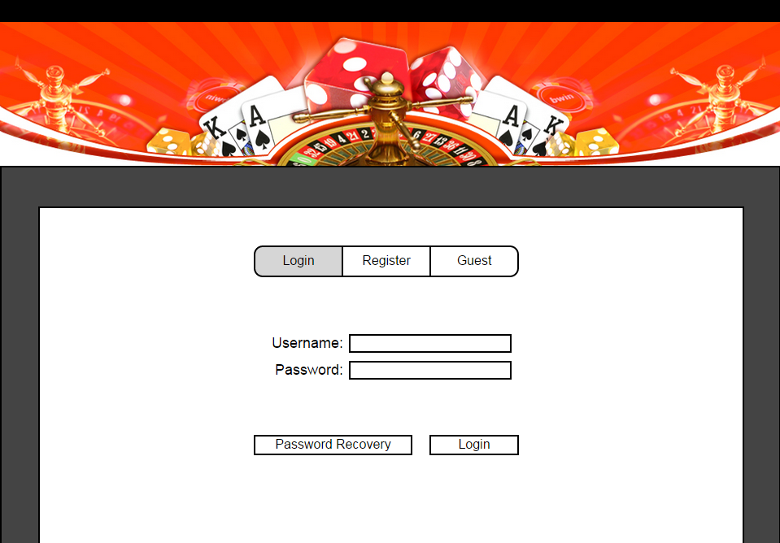

After initial load of the login page, the user will be greeted with the login screen (Figure 1). This screen consists of 3 tabs, user inputs with its labels and 2 buttons. The default selection will be the “Login” tab, highlighted in grey. Clicking the “Register” tab will switch views into the register screen (Figure 3). This does not navigate to another page. It will simply hide the login screen and show the register screen. Clicking the “Guest” tab will navigate to the home page (Figure 5) as a guest. Clicking the “Password Recovery” button will navigate to the password recovery page (Figure 23). After clicking the “Login” button, the user name and password inputs will be validated. If successfully validated, the user will be directed to the home page as the logged in user. When login fails, the input fields will be highlighted in red and an error message will be shown (Figure 2). The error message will indicate the reasoning behind the login fail.

Figure 2 – Login Error

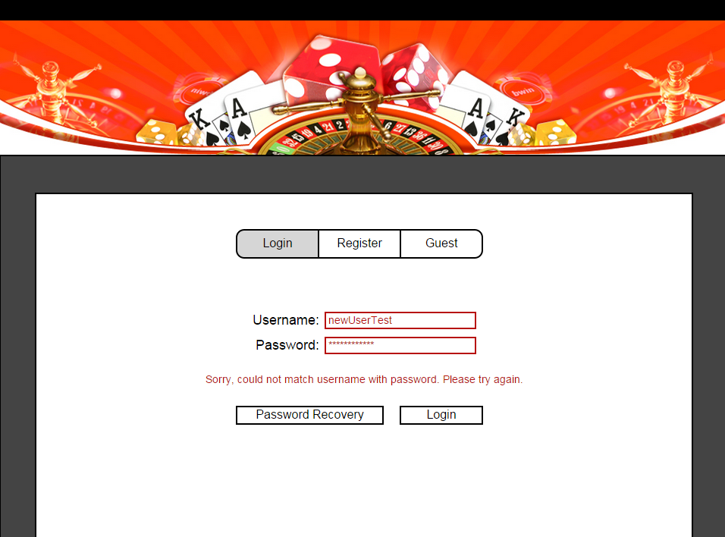

Figure 3 – Register Screen

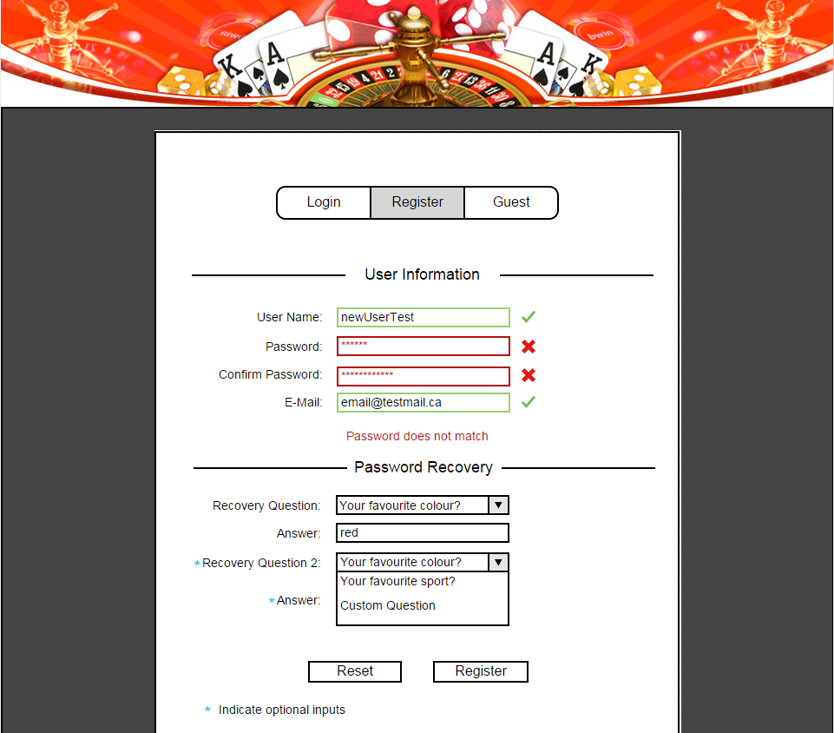

The register screen (Figure 3) has 2 sections, user information and password recovery. The user information section consists of 4 inputs that will have validation. The user name input will only allow letters and numbers, no special characters and spaces will be allowed. The password will have no restrictions in data, only a minimum length of 5 characters. E-mail will check valid e-mail formatting and if the address is already registered. The validations will be done by regular expressions. The password recovery section will contain 2 recovery question dropdown boxes along with their answer inputs. Only the first question is required, the second one is optional for the user. The user could choose from predetermined questions, or an option of creating a custom question. When the user selects the custom question options (Figure 4), a new input box will appear and the user can enter a custom question of their choice. There will be no restrictions on the custom question input. The answer inputs will not allow empty data or just blank spaces. Clicking the reset button will reset the form to default state with empty inputs. When all inputs are validated, the register button will insert new user record into database, user will then be redirected to login screen.

Figure 4 – Password Recovery Questions

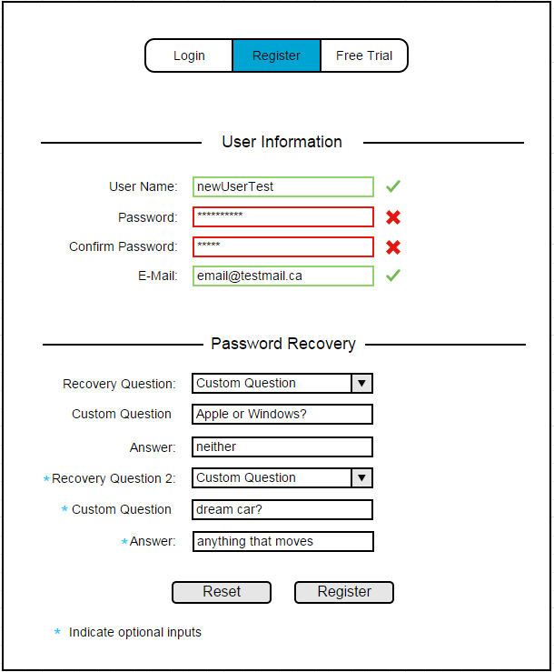

Figure 5 – Home Page



The homepage (Figure 5) will have a user indicator at the top right corner, a header banner, a welcome banner, horizontal navigate menu and a carousel. The user indicator will show guest or the logged in user’s user name. Clicking the indicator will log the user out and redirect to the login screen. The indicator and the header banner will remain the same throughout all the pages. The welcome banner will be below the navigate menu items. The carousel will consist of guide videos, promotions or other news that will rotate every few seconds. Clicking the carousel item will direct the user to the carousel content being displayed. The menu items consist of:

* Home
* Games
* How to Play
* Special Offers
* Member Section - Members and Admin access level
* Purchases - Members and Admin access level
* Messages – Members only
* Admin - Admin only

Figure 6 - Homepage Alternate Carousel



The how to play page (Figure 7) will have two sections. First section will be video tutorials that have embedded YouTube videos for the users to watch. The second section will contain text explanations on how to play Blackjack and card values. The videos can be played on the website itself with full screen capability.

Figure 7 - How to Play Page

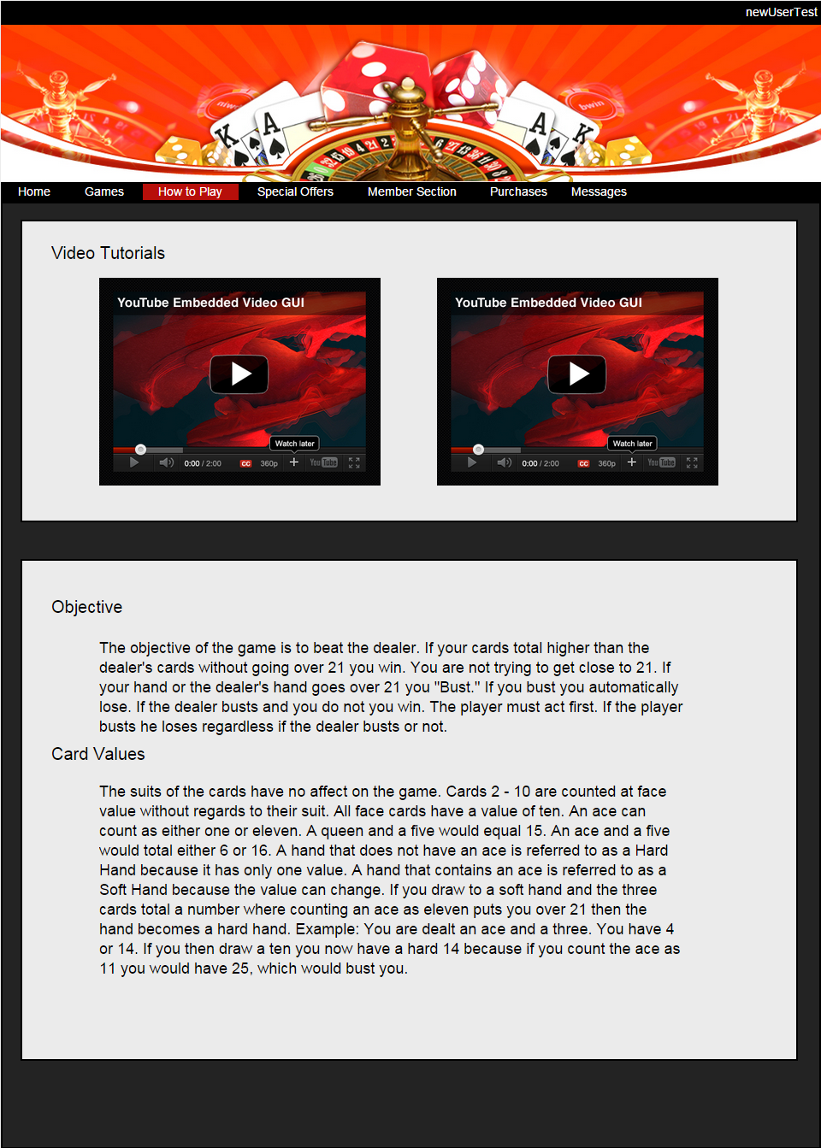

The special offers page (Figure 8) will have current promotions regarding deals on purchasing credits. These items do not have functionality, just display purposes. The two items in figure 8 are examples of possible promotion offers.

Figure 8 – Special Offers Page

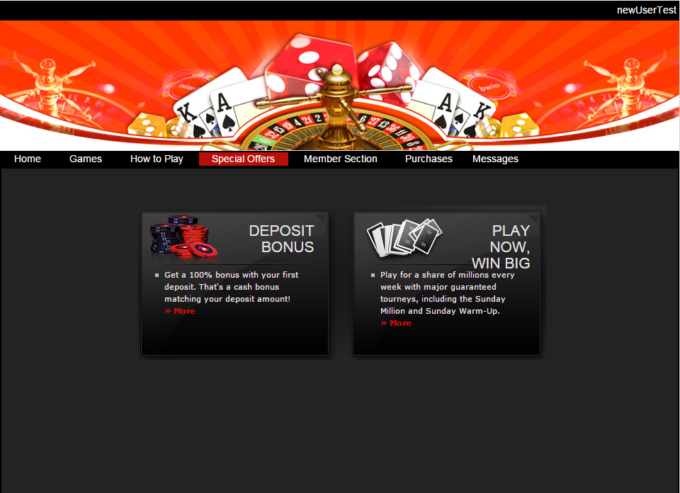

The members page (Figure 9) will have two sections, user information and payment information. The default state of the inputs and the save button will be disabled. When they click the edit button the inputs are enabled and user is able to change their password and e-mail address. The inputs will have the same requirements and validations as the inputs on the register screen. Clicking the save button will update the user information if all inputs are validated. The user is not required to enter payment information, but then they won’t be able to purchase any credits and win money. The user will create a payment method and enter their credit card information into the input fields. The credit card information will be saved under the payment method name. The credit card number and verification code inputs will have placeholders to indicate the proper format and data needed. Credit card number validators will be used to check credit card information. The payment method drop down list will consist of “Visa”, “MasterCard” and “AMEX”. Expiry date drop downs will provide all the months and years up to 2050. Clicking the add payment button will insert a new payment method associated with the user.

Figure 9 - Members Page

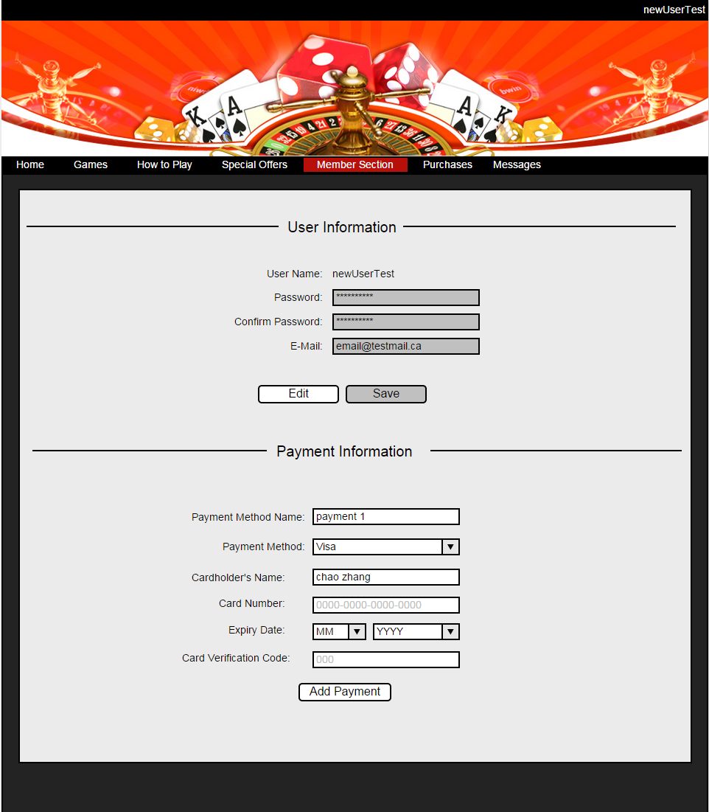

Figure 10 - Members Page Error

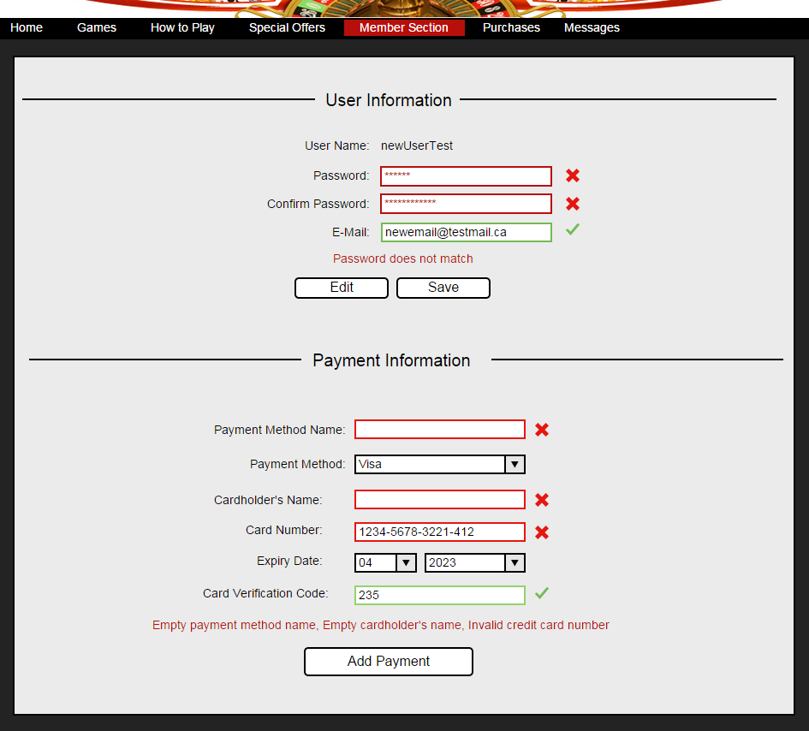

Figure 10 shows whether or not the data in the inputs are valid when entered.

Figure 11 – Purchases Page

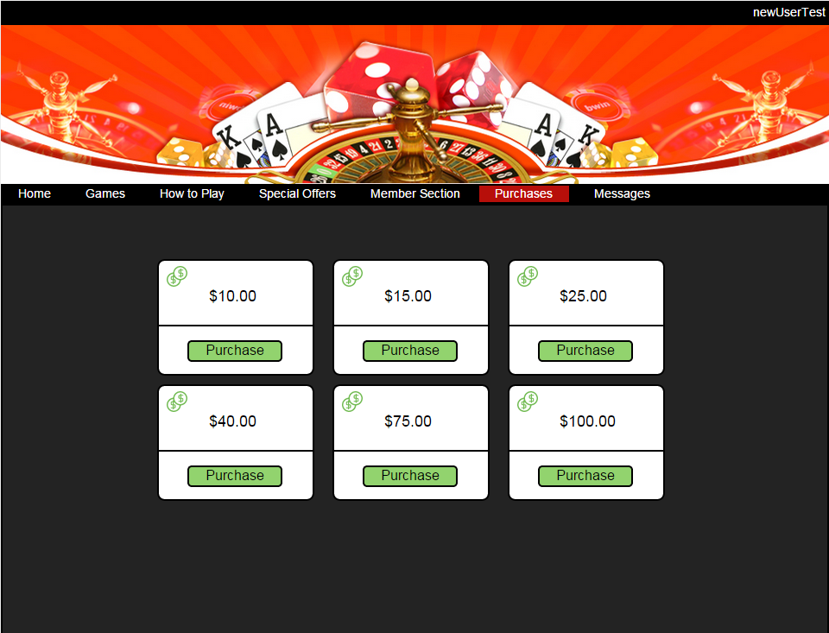

The purchases page (Figure 11) will have 6 credit purchase amounts. These amounts will change based on the special offers. When one of the purchase buttons is pressed, a modal will appear with the purchase confirmation (Figure 12). The purchase confirmation will have the user selecting one of the payment methods and verify the purchase amount is correct. The drop down list will contain all the payment methods set by the user. Clicking the purchase button will process the purchase and add the appropriate amount of credits to the user’s account.

Figure 12 - Purchase Confirmation

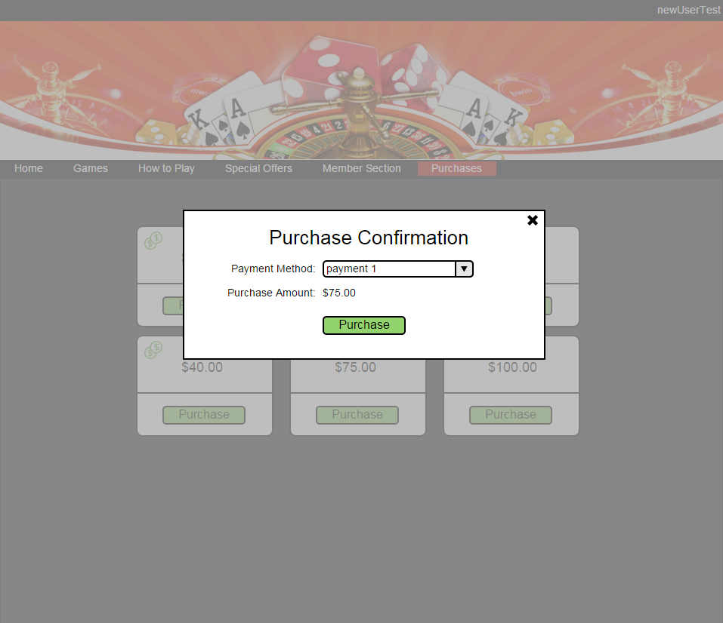

On the game page (Figure 13), there are indicators on the left side showing the available credits and current winnings of the user. To start the game, the user must enter a bet amount into the input on the right side and click the deal button. The bet amount input box will only accept positive integers less than or equal to the user’s available credits (Figure 14).

Figure 13 - Game Page

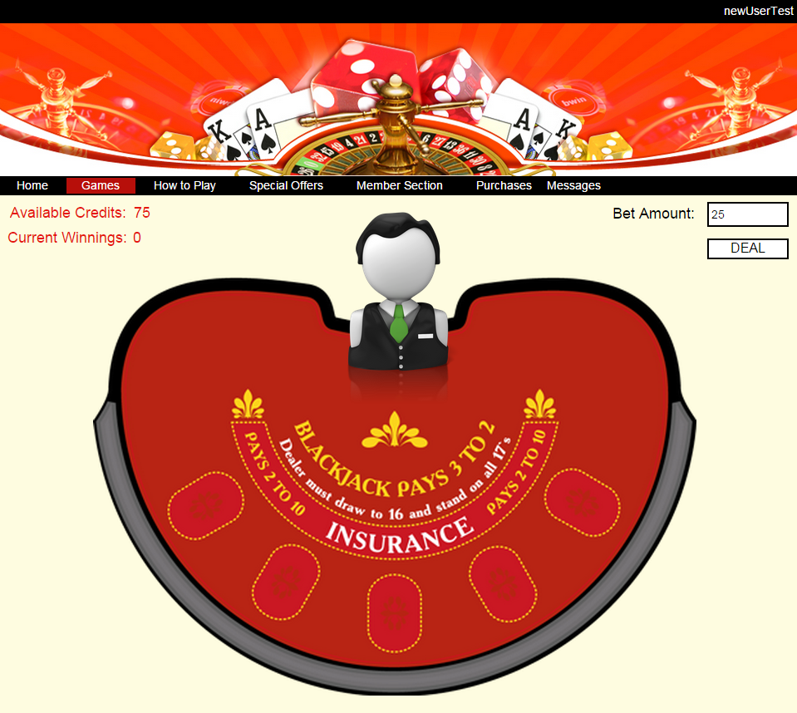

Figure 14 - Bet Amount Error

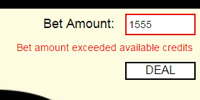

Figure 15 - Game in Progress

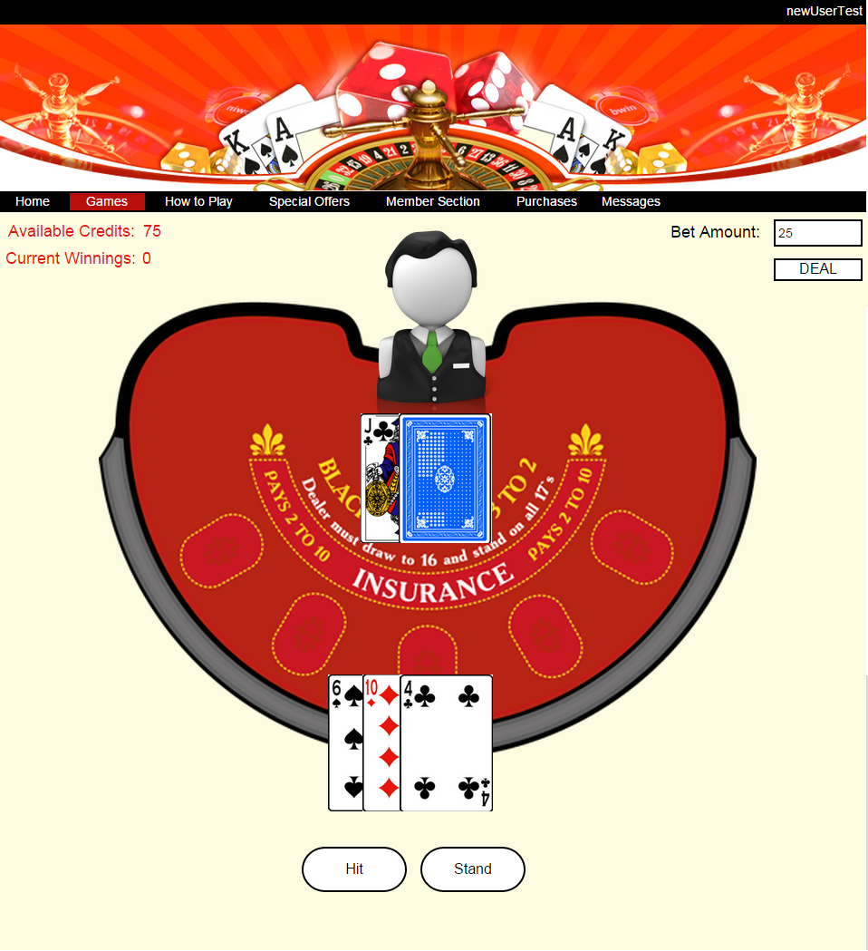

After the game starts, cards are dealt to the user and dealer. Buttons will appear below the playing field based on available choices for the user. In Figure 15, the user already chose to “Hit” after the first round. The available choices now are to either “Hit” again or “Stand”.

Figure 16 - Game Over

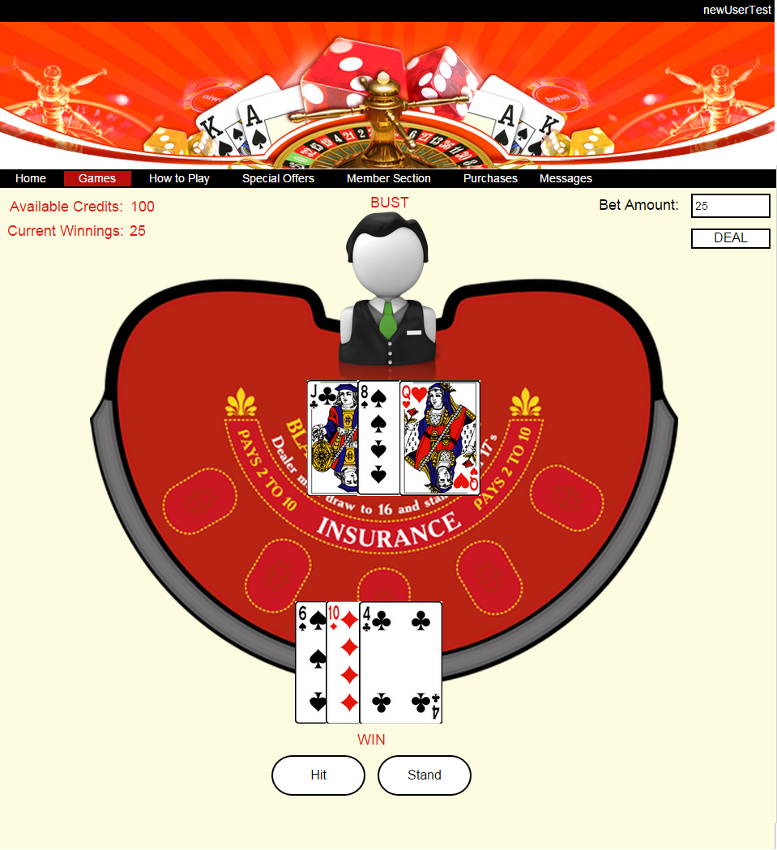

After the game is over, available credits and current winnings will update according to the results of the round. Figure 16 shows the end of a round when the dealer busts, resulted in a win for the user. The available credits and current winnings are now updated.

Figure 17 - Admin User Search

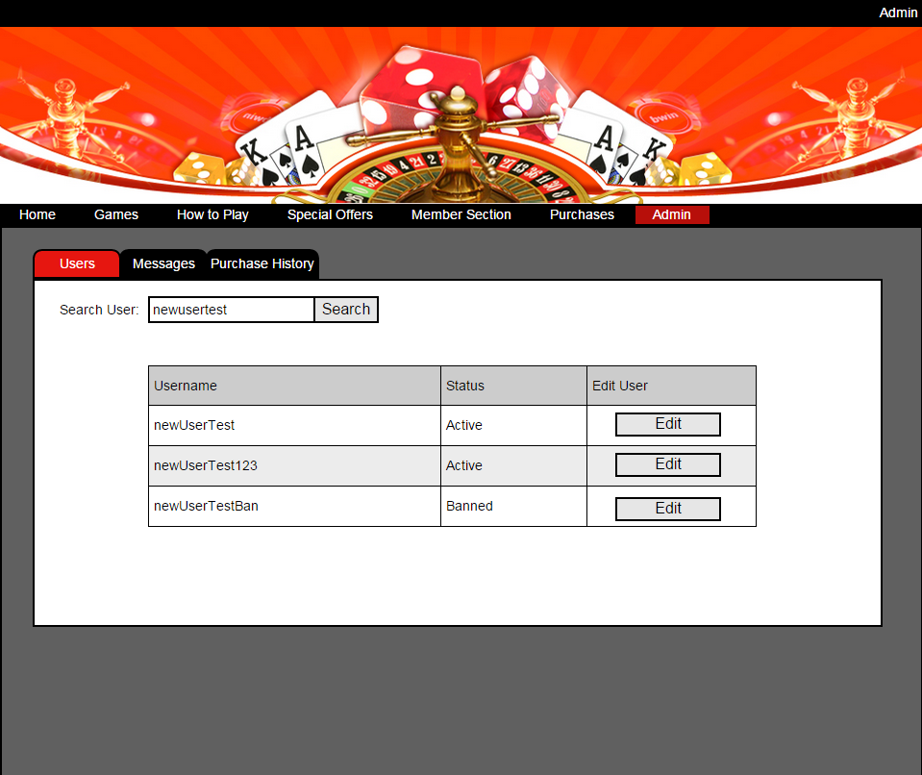

The admin page has three screens of different functionality. The first one is the users screen (Figure 17). On this screen, there is a search input for searching usernames to display in a table. The search string is not case sensitive and will return any results that contain the string. In this case, all the results contain “newusertest”. If the string is empty, the search will return all of the users. The table will display username, status of the user and a button to edit that user’s information.

Figure 18 - No Results

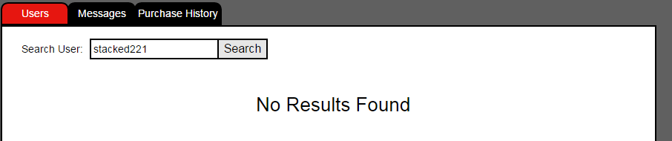

When the edit button is clicked for the specific user, a new modal window (Figure 19) will open with all of the user’s information to edit. All the inputs are disabled until the edit button on this screen is clicked. The inputs will have the same data requirement and validation as the register screen. Clicking the ban button will update the database and set the user’s status to ban, the user now can’t login. If the user is already banned, this button will change to unban and it will set the status of the user to active if clicked.

Figure 19 - Admin User Edit Modal

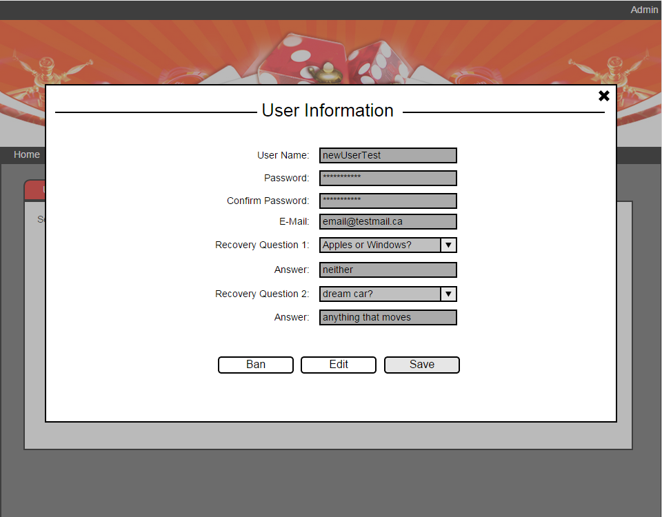

The admin messages screen (Figure 20) will have the same functionality as a regular user’s message screen (Figure 21). On this screen, a table of messages received will be displayed. By default it will be sorted by the latest date. Checking the checkbox of the row will allow the user to delete one or multiple selected messages. A message modal window (Figure 22) will open up to display the message content when any of the message rows is clicked. This window is also used by regular user’s message display. Search message string will search sender, subject and date it will then return any matched results to the table. The table will have pagination if messages exceed 50. Each page will hold 50 rows of message.

Figure 20 - Admin Message Screen

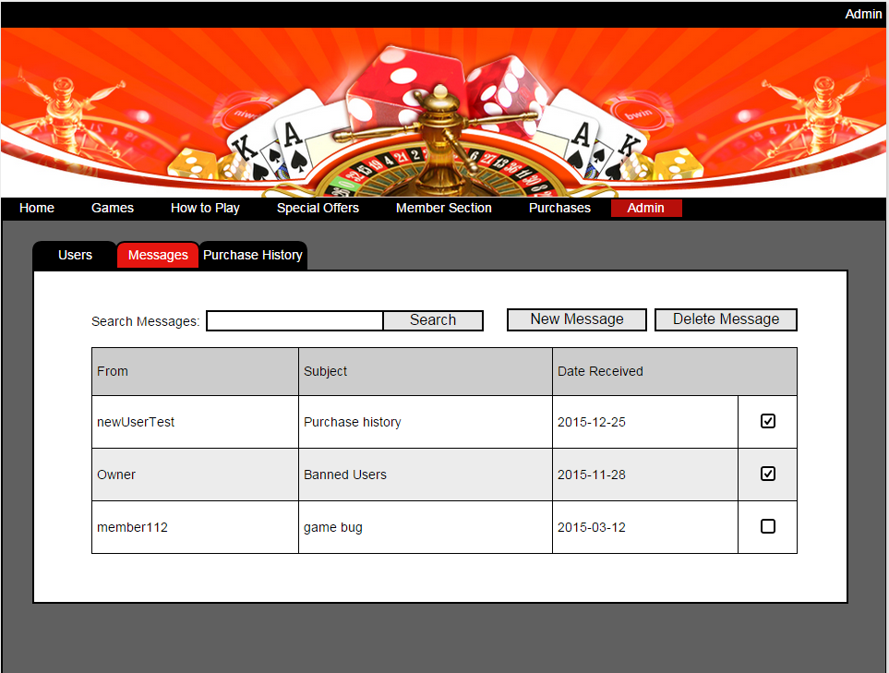

Figure 21 - User Message Screen

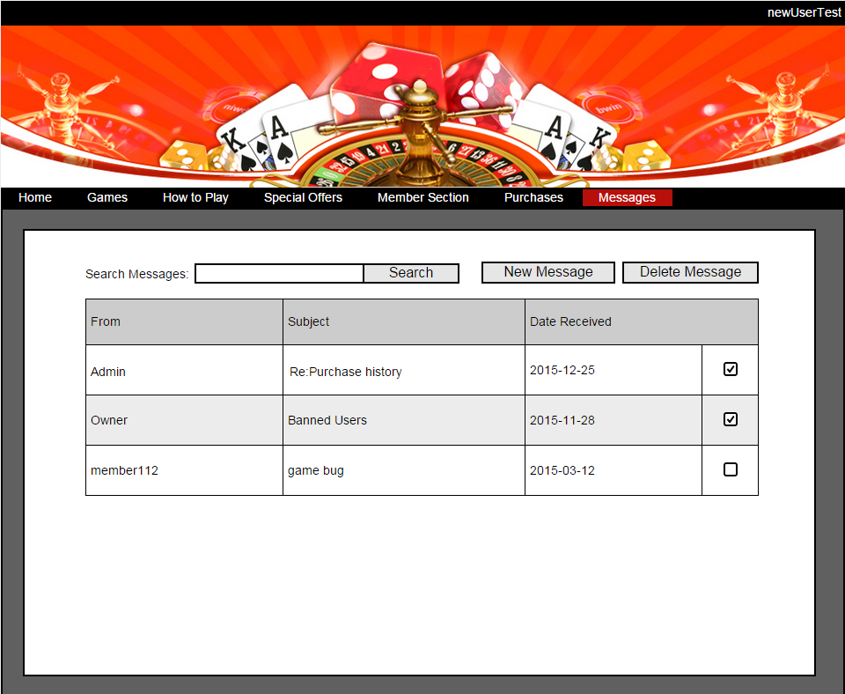

Figure 22 - Message Content

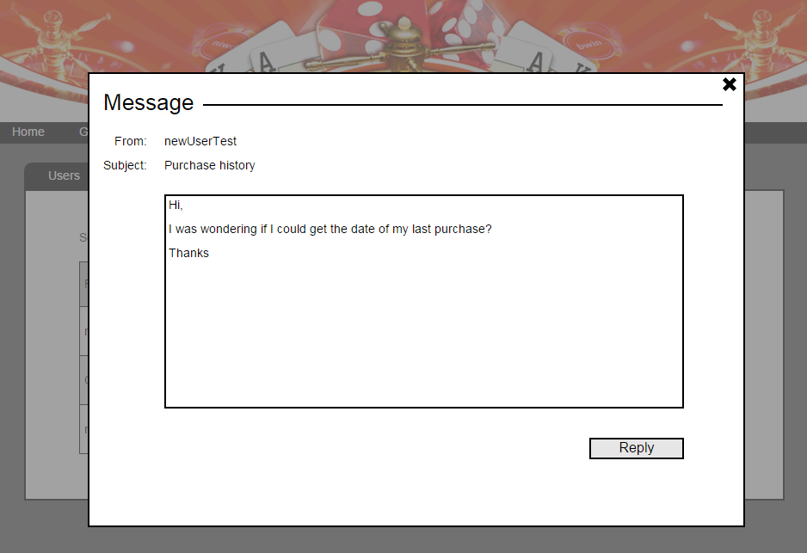

Clicking the reply button on the message modal window will redirect to new message screen (Figure 23) but with the inputs prepopulated except the message content. Messages can be sent to multiple recipients. The subject input can be empty, no restriction on data input. The input has to be separated by commas (receiver1, receiver2, receiver3). The message content text box has a 1000 character limit with no data restrictions.

Figure 23 - New Message Window

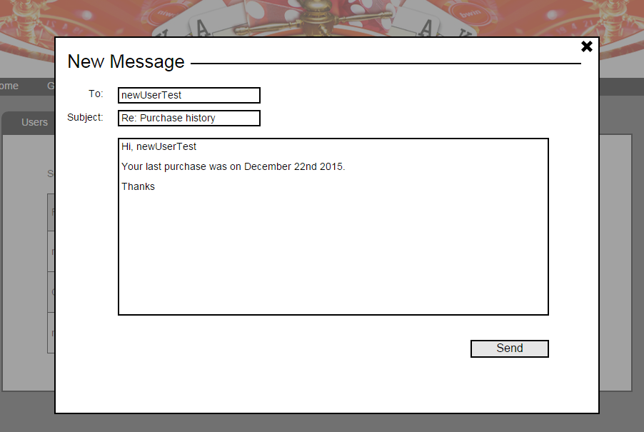

When the user clicks the send button, a new message will be created in the database associated with the recipient. If the recipient does not exist, an error message will be shown.

Figure 24 - New Message Error

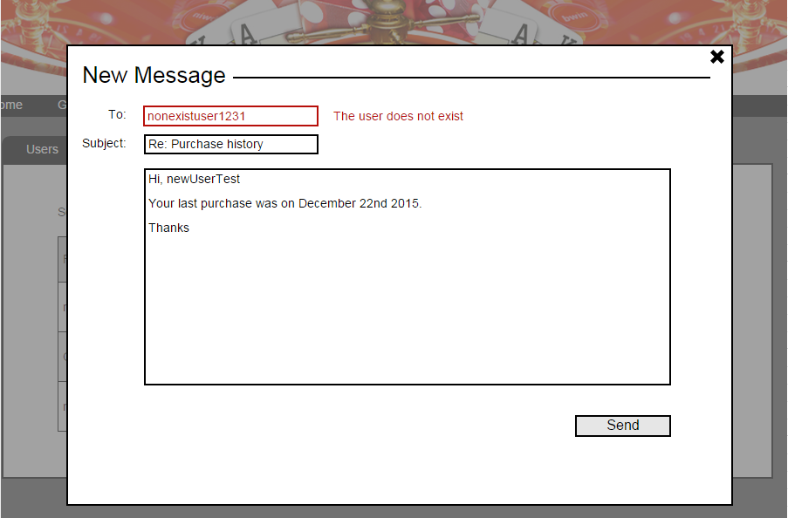

Figure 25 - Admin Purchase History Search Screen

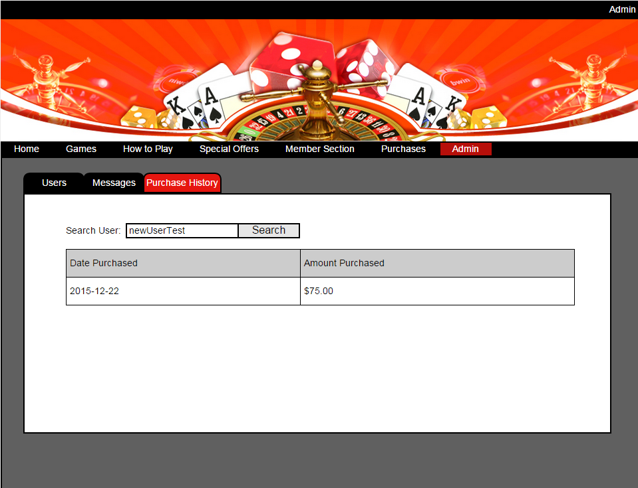

The last admin screen is the purchase history screen (Figure 25). The admin can search for the purchase record of any user by user name. The table will display the user’s purchase record sorted by latest date. This table will also have pagination if the records exceed 50, similar to the messages table. If the input is empty or the user doesn’t exist, the search will return no results. It will be displayed like figure 18.

Figure 26 - Password Recovery Page

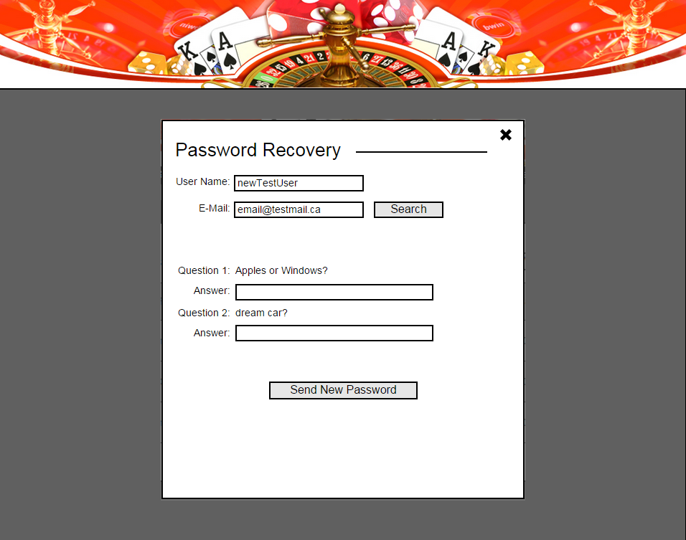

The password recovery page (Figure 26) has a user name and e-mail search input. This input will search for the password recovery questions associated with the user name and e-mail address. Then the questions will show up on the screen. If the user entered the correct answers for the questions, a new password will be generated and sent to the e-mail address. If the user name and e-mail address don’t match, there will be an error message. If the answers don’t match, there will also be an error message. The e-mail input will have format validation.

Figure 27 - Password Recovery Error

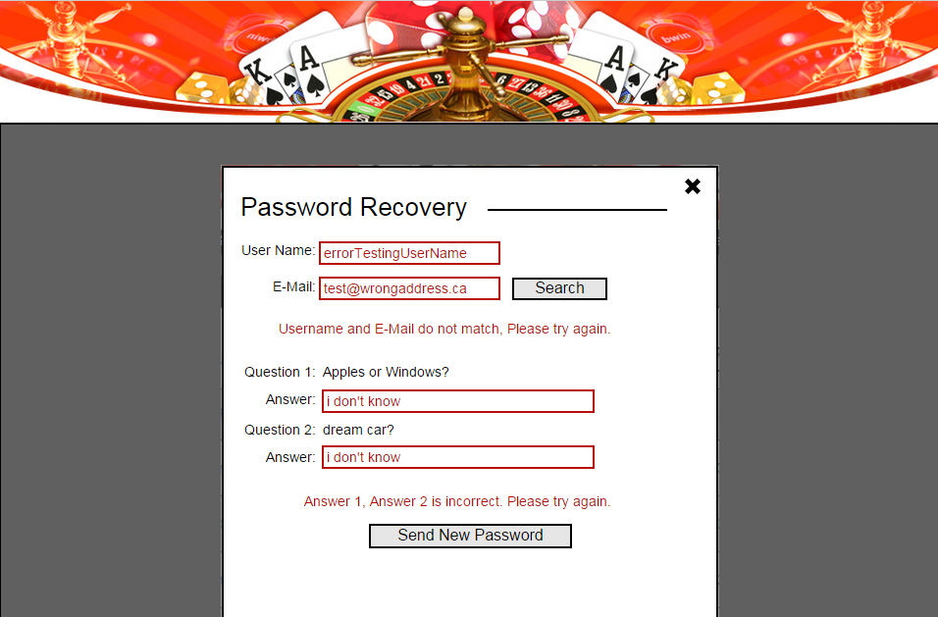

Stacked Deck Database Schema

|  |  |  |
| --- | --- | --- |
| SD_USERS | |  |
| USER_ID | INT - AUTO INCREMENT |  |
| USER_NAME | VARCHAR(50) |  |
| USER_PASSWORD | VARCHAR(50) - ENCRYPTED |  |
| USER_EMAIL | VARCHAR(50) |  |
| USER_RECOVERY_QUESTION | VARCHAR(50) |  |
| USER_RECOVERY_ANSWER | VARCHAR(50) |  |
| USER_RECOVERY_QUESTION_2 | VARCHAR(50) |  |
| USER_RECOVERY_ANSWER_2 | VARCHAR(50) |  |
| USER_STATUS | VARCHAR(10) | Active or Banned |
| USER_CREDIT | INT | Amount of credits |
| USER_TYPE | VARCHAR(10) | Admin or User |

|  |  |
| --- | --- |
| SD_PAYMENTS | |
| PAYMENT_ID | INT - AUTO INCREMENT |
| USER_ID | INT |
| PAYMENT_NAME | VARCHAR(50) |
| CARD_TYPE | VARCHAR(50) |
| CARD_NUMBER | INT - ENCRYPTED |
| CARD_VERIFY_CODE | INT - ENCRYPTED |
| CARD_EXP_DATE | TIMESTAMP |
| CARD_HOLDER_NAME | VARCHAR(50) |

|  |  |
| --- | --- |
| SD_PURCHASES | |
| PURCHASE_ID | INT - AUTO INCREMENT |
| USER_ID | INT |
| PAYMENT_NAME | VARCHAR(50) |
| PURCHASE_DATE | TIMESTAMP |
| PURCHASE_AMOUNT | INT |

|  |  |
| --- | --- |
| SD_MESSAGES | |
| MESSAGE_ID | INT - AUTO INCREMENT |
| USER_ID | INT |
| SENDER_NAME | VARCHAR(50) |
| RECEIVER_NAME | VARCHAR(50) |
| CONTENT | VARCHAR(1000) |
| SUBJECT | VARCHAR(50) |
| SEND_DATE | TIMESTAMP |

Database ERD

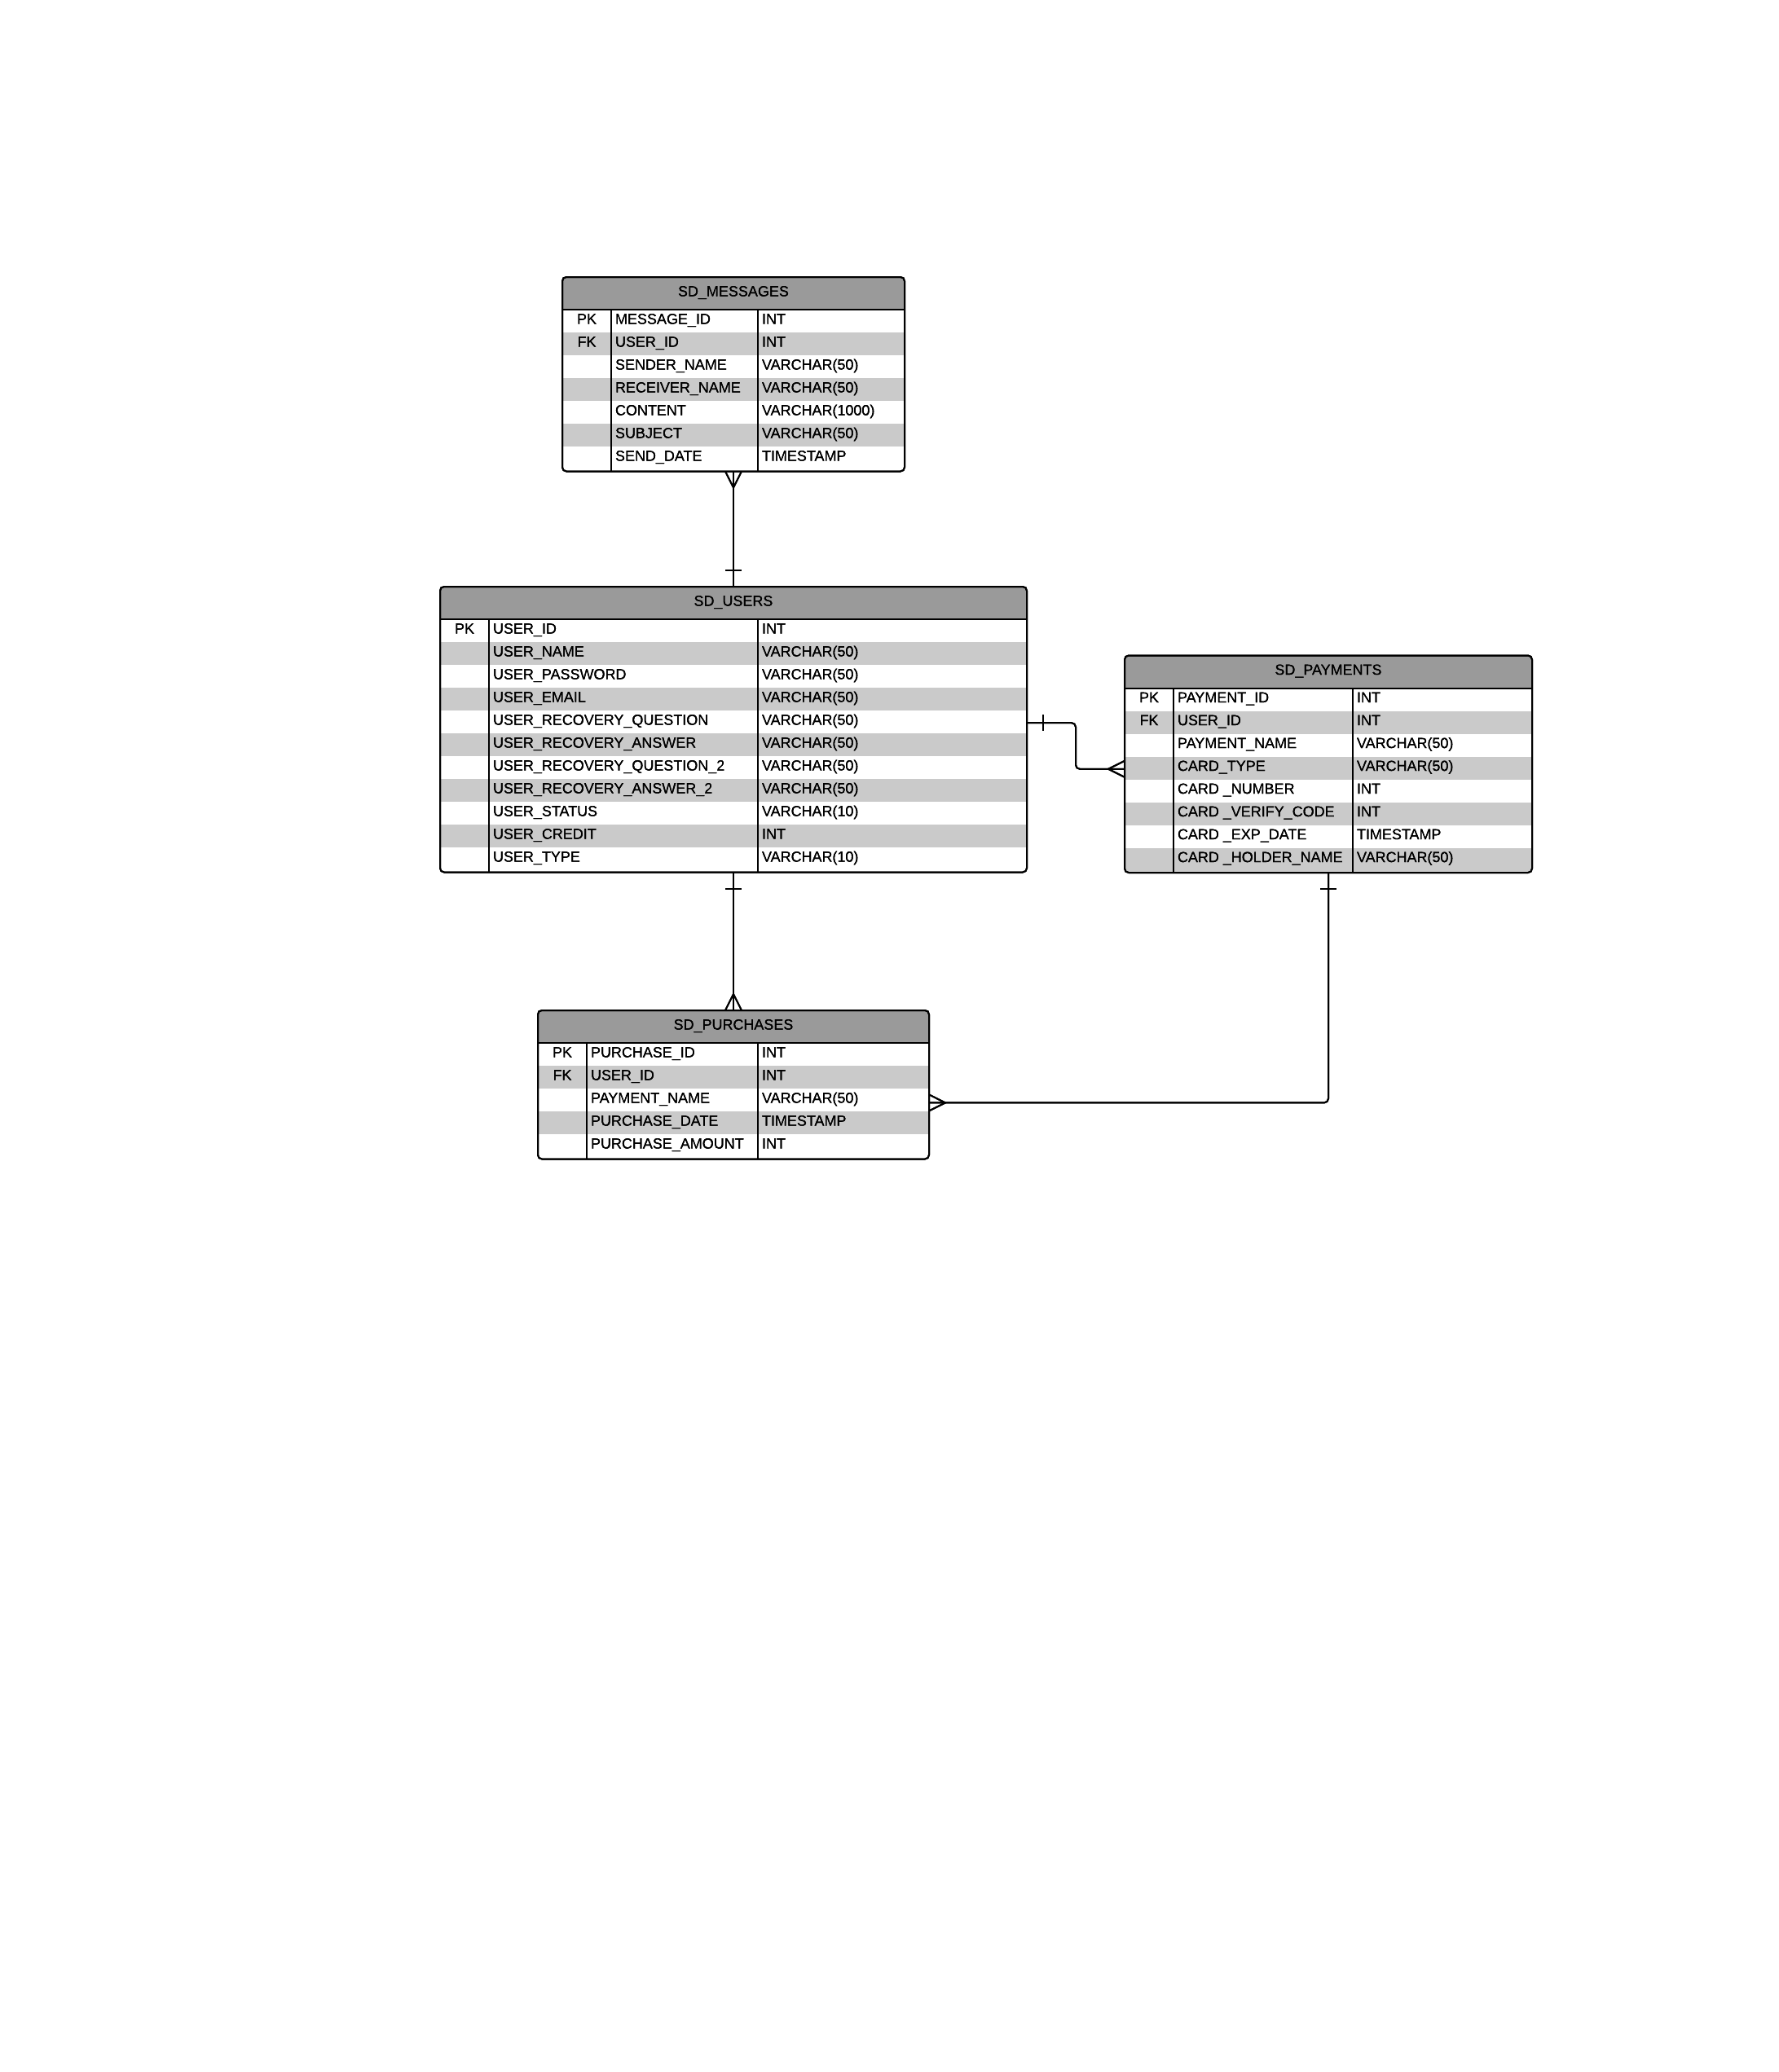

Testing Plan

*Test to Pass*

* Login
  + Proper login credentials
  + Login redirect
  + Logout redirect
* Registration
  + Proper data entry
  + Registration Redirect
* Homepage
  + Carousel redirect
* How to Play
  + Embedded videos playing
* Members page
  + Proper data entry
* Purchases
  + Amount purchase added to user credit
* Game page
  + Correct game logic/winning condition
  + Proper bet amount
  + Winnings updating correctly
* Admin
  + User search showing results unless no user registered
  + User edit proper data entry
  + User status change
  + Purchase history showing results unless no purchase record
* Messages
  + Create, read, send, delete messages
* Password Recovery
  + Proper data entry
  + Questions auto populate

*Test to Fail*

* Improper data entry on all forms that have validation
* Creating existing user/using existing e-mail to register
* Improper page navigation based on restriction level

As the developer, I will be testing this project with irregular data trying to find as many security loop-holes as possible. I will be using Selenium to help with the testing. Black-box testing method will be done by beta testers. All testing will be done on Internet Explorer, Mozilla FireFox, Google Chrome and Safari. I will host a Google doc for all the testers to record bugs in.

Challenges

The biggest challenge of this project is the game portion of it. I need to account for all possible outcomes according to the rules of the game. The next biggest challenge will be the database portion. I need to make sure all the data types are appropriate for the scope of this project. I am not as familiar with back-end technologies as I am with front-end. I need to put extra effort into this portion to make sure the procedures and queries are correct along with data encryption. The last thing I’m concerned with is the validation part of this project. I will be working with regular expressions with form validation and algorithms for different types of credit cards to validate.

Resources

<https://msdn.microsoft.com/en-ca>

<http://en.wikipedia.org/wiki/Blackjack>

<http://getbootstrap.com/>

<https://jquery.com/>

<https://msdn.microsoft.com/en-us/library/bb545450.aspx>

<http://www.browserstack.com/>

<https://www.google.ca/>

Project Planning

|  |  |  |
| --- | --- | --- |
| Week 1  Sept 8th - Sept 13th |  | * Create project foundation on Visual Studio * Create SQL Database with all tables * Create starter files for all webpages |
| Week 2  Sept 14th – Sept 20th |  | * Establish database connection * Start creating all the layout of every page   + Login Page   + Home Page   + Special Offers Page |
| Week 3  Sept 21st – Sept 27th |  | * Continue website layout   + How to Play Page   + Members Page   + Purchases Page |
| Week 4  Sept 28th – Oct 4th |  | * Continue website layout   + Game Page   + Admin Page   + Messages Page   + Password Recovery Page * Start development on Blackjack game |
| Week 5  Oct 5th – Oct 11th |  | * Continue development on Blackjack game * Start development on functionality   + Login Page with SQL procedures   + Home Page   + How to Play Page |
| Week 6  Oct 12th – Oct 18th |  | * Continue development on Blackjack game * Continue development on functionality   + Members Page   + Add new payment with SQL procedures   + Purchases Page with SQL procedures |
| Week 7  Oct 19th – Oct 25th |  | * Continue development on Blackjack game * Continue development on functionality   + Admin Page searches with SQL procedures   + Messages Page searches with SQL procedures |
| Week 8  Oct 26th – Nov 1st |  | * Continue development on Blackjack game * Continue development on functionality   + Password Recovery Page searches with SQL procedures |
| Week 9  Nov 2nd – Nov 8th |  | * Continue development on Blackjack game   + Update credits and winnings |
| Week 10  Nov 9th – Nov 15th |  | * Finish up any leftover pages * Start alpha testing * Start beta testing |
| Week 11  Nov 16th – Nov 22nd |  | * Continue alpha testing * Continue beta testing |
| Week 12  Nov 23rd – Nov 29th |  | * Finish alpha testing * Finish beta testing * Start fixing outstanding issues |
| Week 13  Nov 30th – Dec 6th |  | * Start presentation prep * Continue fixing outstanding issues |
| Week 14  Dec 7th – Dec 13th |  | * Finish fixing outstanding issues * Finish project * Finish presentation |